Ranking + Results

 | Csapat / Team | 1. kör /round | 2. kör /round | 3. kör /round | 4. kör /round | 5. kör /round | Final | Total point | Ends | Stones
1. | Y. Nekrasova &  P. Dron (RUS) | 4-6  3-5 | 13-10  4-4 | 13-8  4-4 | 15-1  7-1 | 8-6  3-5 | 9-7  3-5 | 8+2 | 21+3 | 53+9
2. | I. Szekeres &  Gy. Nagy (HUN) | 6-4  5-3 | 6-4  5-3 | 11-3  5-3 | 9-5  5-3 | 14-2  6-2 | 7-9  5-3 | 10 | 26+5 | 46+7
3. | G. Kajanova &  M. Kajan (SVK) | 12-4  5-3 | 7-2  6-2 | 9-4  5-3 | 5-9  3-5 | 6-8  5-3 | 8-3  5-2 | 6+2 | 24+5 | 39+8
4. | O. Rókusfalvy &  T. Szabad (HUN) | 15-3  5-3 | 6-7  4-4 | 3-11  3-5 | 9-5  4-4 | 9-8  4-4 | 3-8  2-5 | 6 | 20+3 | 42+2
5. | B. Páthy-Dencső &  Gy. Pomázi (HUN) | 2-14  1-7 | 10-3  5-3 | 9-6  5-3 | 4-10  3-5 | 7-5  5-3 |  | 6 | 19 | 32
6. | M. Lelovics &  L. Pahocsa (HUN) | 4-12  3-5 | 8-5  4-4 | 7-6  4-4 | 10-4  5-3 | 2-14  2-6 |  | 6 | 18 | 31
7. | Á. Patonai &  P. Sárdi (HUN) | 4-10  4-4 | 10-13  4-4 | 6-9  3-5 | 17-1  7-1 | 17-5  5-3 |  | 4 | 23 | 54
8. | C. Lucas &  F. Christensen (LUX&DEN) | 3-15  3-5 | 3-10  3-5 | 10-6  4-4 | 5-7  5-3 | 7-3  5-3 |  | 4 | 20 | 31
9. | Cs. Halász &  G. Ézsöl (HUN) | 10-4  5-3 | 2-7  2-6 | 6-7  4-4 | 7-5  3-5 | 8-9  4-4 |  | 4 | 18 | 32
10. | M. Szabon &  Gy. Kalmár (HUN) | 14-2  7-1 | 7-6  4-4 | 4-9  3-5 | 1-15  1-7 | 5-17  3-5 |  | 4 | 17 | 30
11. | J. Clark &  J. Sharp (ENG) | 10-4  4-4 | 4-6  3-5 | 8-13  4-4 | 5-9  4-4 | 3-7  3-5 |  | 2 | 18 | 30
12. | M. Kajanova &  M. Kajan (SVK) | 4-10  3-5 | 5-8  4-4 | 6-10  4-4 | 1-17  1-7 | 5-7  3-5 |  | 0 | 15 | 21

SPONZORS:

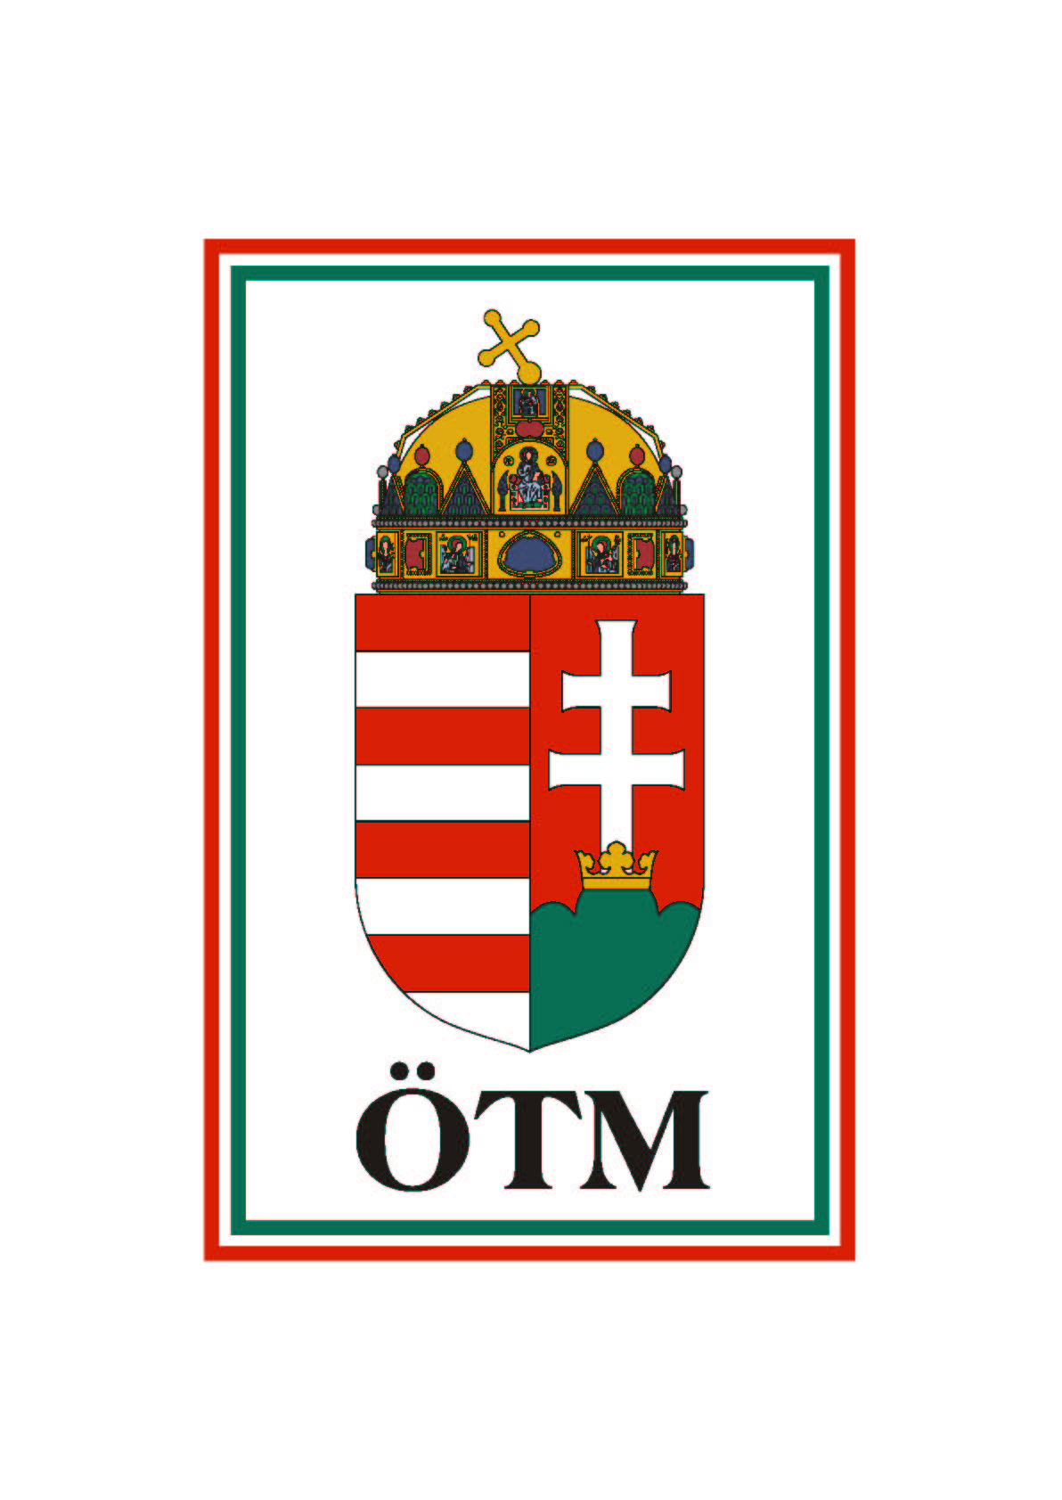 |  |  | 